# Life Skill Workshop

## Day-1

Session1

The workshop was started at 10am on 25th November, 2019. Our Principal, Dr. Ancy Jose, motivated the students by a motivational speech followed by the College Anthem and also shared her past experience regarding this life skill workshop. She also requested us and explained the importance of this type of such workshop. The Vice Principal, Mr. Suchak gave a speech about the meaning and importance of our college anthem. Then we had a speech by our Co-ordinator, MS. Sindhu Ma’am in which she introduced us to the workshop leader Dr. Sujata Singhi about what work she had done it earlier and how much she contributed through the medium of this workshop. After that Dr.Sujata Singhi then divided students into groups.

Session2

This session included the explanation of values and gratitude of our life. Dr. Sujata Singhi explained her life-story by sharing some of her personal life example. She made us realize the importance of everything in our life. There was a dance video which was followed by everyone. In this session there was also a group activity in which students have to pick any product of their own imagination and to sell them by using marketing tactics. Then students took a declaration oath.

## Day-2

Session1

The session started with a brief explanation about the previous day which was followed by an energetic dance. Then some students shared their experience about the task which was assigned on previous day which motivated each and every person in the auditorium. The students were given a group activity of making a spaceship for the princess by her requirements, terms and conditions. This activity helped the students to understand the concept of team-work and leadership and an opportunity to make our self-growth and exchange in our ideology

Session2

This session had a rockstar event were every student had to dress like a rockstar and become a rockstar and perform on the stage. The students were made to give the name of the rockstar and their song. This activity helped the students to eliminate their stage fear and perform freely on the stage. The session ended with the dance.

## Day-3

Session1

### The session started with a brief explanation about the previous day which was followed by an energetic dance. After dance we were given a individual task of making our own vision board in which were allowed to include our own vision that what we see for ourselves. Ma’am gave the importance of music, sound and rhythm in our life through various musical instruments where she explained the importance of the effect of different types of sound in our mind, she also made us understand the comparison between the music an our life

Session2

The session started with Meditation Act followed by the declaration oath. Then we had the felicitation of the workshop leader Dr .Sujata Singhi. Then we had the Certificate Distribution of the students and the crew members. At the end, we had the Vote of Thanks by the students, crew members and the respected faculty. We also sang a song and made us feel powerful. Then we all had group photo with her and we all were given a feedback.

## P2: Green Computing

## Definition:

Green computing is the environmentally responsible and eco-friendly use of computers and their resources. In broader terms, it is also defined as the study of designing, engineering, manufacturing, using and disposing of computing devices in a way that reduces their environmental impact.

## Use of green computing:

Minimizing the electricity consumption of computers and their peripheral devices and using them in an eco-friendly manner

 Designing energy-efficient computers, servers, printers, projectors and other digital devices

## Disposal of green computing:

Repurposing existing equipment or appropriately disposing of, or recycling, unwanted electronic equipment

## Manufacturing of green computing:

Minimizing waste during the manufacturing of computers and other subsystems to reduce the environmental impact of these activities

Government regulatory authorities also actively work to promote green computing concepts by introducing several voluntary programs and regulations for their enforcement. Average computer users can employ the following tactics to make their computing usage more. Use hibernate or sleep mode when away from a computer for extended periods. Buy energy-efficient notebook computers, instead of desktop computers

### Activate the power management features for controlling energy consumption

### Make proper arrangements for safe electronic waste disposal

### Turn off computers at the end of each day

### Refill printer cartridges, rather than buying new ones

### Instead of purchasing a new computer, try refurbishing an existing device

**Conclusion:**

Through the effort of developing sustainable energy, we can create a better quality of life for the coming generation. We can put our effort to learn more about knowledge of computer disposal to protecting the environment. By green computing technology, we are trying to make the whole process surrounding computers more friendly to the environment, economy and society.

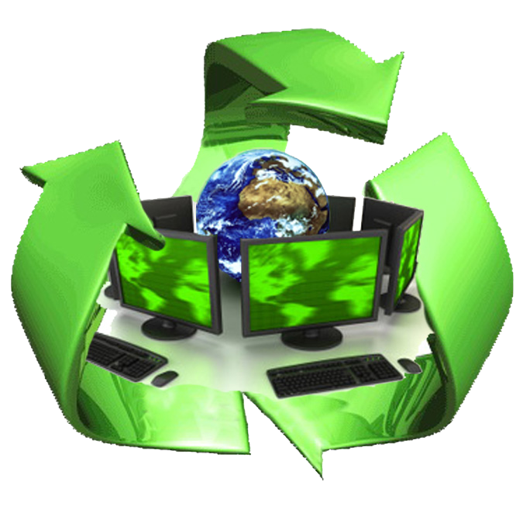

**P3: FREE AND OPEN SOURCE**

"**Free and open-source software**" (**FOSS**) is an umbrella term for software that is simultaneously considered both [Free software](https://en.wikipedia.org/wiki/Free_software) and [open-source software](https://en.wikipedia.org/wiki/Open-source_software). FOSS (free and open-source software) allows the user to inspect the source code and provides a high level of control of the software's functions compared to [proprietary software](https://en.wikipedia.org/wiki/Proprietary_software). The term "free software" does not refer to the monetary cost of the software at all, but rather whether the license maintains the software user's civil liberties ("free” as in “free speech,” not as in “free beer”) There are a number of related terms and abbreviations for free and open-source software (FOSS or F/OSS), or free/libre and open-source software (FLOSS or F/LOSS—FLOSS is the FSF-preferred term).

Although there is almost a complete overlap between [free-software](https://en.wikipedia.org/wiki/Free_software) licenses and [open-source-software](https://en.wikipedia.org/wiki/Open-source_software) licenses, there is a strong philosophical disagreement between the advocates of these two positions. The terminology of FOSS or "Free and Open-source software" was created to be a neutral on these philosophical disagreements between the FSF and OSI and have a single unified term that could refer to both concepts.

**Free software**

[Free Software Definition](https://en.wikipedia.org/wiki/Free_Software_Definition), adopted by the [Free Software Foundation](https://en.wikipedia.org/wiki/Free_Software_Foundation) (FSF), defines [free software](https://en.wikipedia.org/wiki/Free_software) as a matter of liberty not price, and it upholds the Four Essential Freedoms. The earliest-known publication of the definition of his free-software idea was in the February 1986 edition of the FSF's now-discontinued GNU's Bulletin publication. The canonical source for the document is in the philosophy section of the [GNU Project](https://en.wikipedia.org/wiki/GNU_Project) website. As of August 2017, it is published there in 40 languages.

**Four essential freedoms of Free Software**

To meet the definition of "free software", the FSF requires the software's licensing respect the civil liberties / human rights of what the FSF calls the software user's "[Four Essential Freedoms](https://en.wikipedia.org/wiki/The_Free_Software_Definition#The_definition_and_the_Four_Freedoms)".The freedom to run the program as you wish, for any purpose (freedom 0).

The freedom to study how the program works, and change it so it does your computing as you wish (freedom 1). Access to the source code is a precondition for this.

The freedom to redistribute copies so you can help others (freedom 2).

The freedom to distribute copies of your modified versions to others (freedom 3). By doing this you can give the whole community a chance to benefit from your changes. Access to the source code is a precondition for this

**Open source**

The [open-source-software definition](https://en.wikipedia.org/wiki/Open_Source_Definition) is used by the [Open Source Initiative](https://en.wikipedia.org/wiki/Open_Source_Initiative) (OSI) to determine whether a [software](https://en.wikipedia.org/wiki/Computer_software) license qualifies for the organization's insignia for [Open-source software](https://en.wikipedia.org/wiki/Open-source_software). The definition was based on the [Debian Free Software Guidelines](https://en.wikipedia.org/wiki/Debian_Free_Software_Guidelines), written and adapted primarily by [Bruce Perens](https://en.wikipedia.org/wiki/Bruce_Perens). Perens did not base his writing on the Four Essential Freedoms of free software from the [Free Software Foundation](https://en.wikipedia.org/wiki/Free_Software_Foundation), which were only later available on the web.[[14]](https://en.wikipedia.org/wiki/Free_and_open-source_software#cite_note-15) Perens subsequently stated that he felt [Eric Raymond](https://en.wikipedia.org/wiki/Eric_S._Raymond)'s promotion of Open-source unfairly overshadowed the Free Software Foundation's efforts and reaffirmed his support for Free software. In the following 2000s, he spoke about open source again